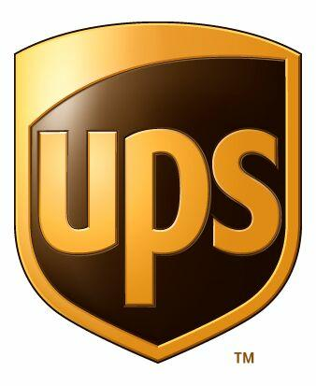Contacts: Dana Benešová, UPS Czech Republic

+420 235 090 963

Karla Krejčí, Donath Business & Media

+420 224 211 220

karla.krejci@dbm.cz

Stefan Bueldt, UPS Europe Public Relations

sbueldt@ups.com

UPS expands Special Commodities program to More Countries
service for shipping biological samples, specimens and dangerous goods in excepted quantities now available in more than 50 nations

Prague, March 9, 2015 — UPS® (NYSE: UPS) today announced a major expansion to its International Special Commodities (ISC) program. Now, customers can ship biological substances, dangerous goods in excepted quantities and shipments utilizing dry ice via UPS to more than 20 additional international destinations.

The expansion is a direct response to a growing demand from biopharmaceutical manufacturers, diagnostics companies, laboratories and distributors to ship these specialized commodities when security, time and temperature control are a high priority.

“The UPS global transportation network has been enhanced to move biological specimens to and from more than 50 countries around the world,” said John Menna, UPS vice president of global strategy, healthcare logistics. “The expanded program was guided by our customers to include the locations that are most important to them.”

UPS is now able to pick up and deliver packages under regulation UN3373 (Biologic Substances, Category B, Diagnostic Specimen and Clinical Specimen) as well as UN1845 (Carbon Dioxide, solid or dry ice) in Australia, Bulgaria, Croatia, Estonia, India, Indonesia, Israel, Latvia, Lithuania, New Zealand, Panama, Romania, Russia*, Saudi Arabia*, Slovakia, Slovenia, South Africa, Taiwan, Turkey and Ukraine.

UN3373 and UN1845 are guidelines issued by the International Air Transport Association (IATA) to regulate the safe transportation of goods using air transportation modes. A full list of approved countries and categories accepted by UPS can be found on UPS.com.

Healthcare and life science companies shipping high-value, time- and temperature-sensitive shipments to, from and within the U.S. and key European markets, also have access to UPS Proactive Response® Secure – a solution combining shipment monitoring and risk management to mitigate product spoilage. The service helps critical shipments reach their destinations even if unexpected events occur and covers potential losses if products are damaged or spoiled.

UPS delivers value to healthcare companies through a broad portfolio of specialized freight and small package transportation and distribution services. UPS’s healthcare network also offers services such as temperature-sensitive storage and transportation, geography-specific regulatory compliance, around-the-clock monitoring and security, kitting and labeling as well as order management and accounts receivable. Services across all locations are accessible via one global IT order management platform. UPS helps healthcare companies meet stringent and often complex regulatory requirements, provides flexibility for a changing business environment, and reliably serves an increasingly global customer base.

For more information on UPS’s healthcare logistics capabilities, visit: www.ups.com/healthcare.

About UPS
UPS (NYSE: UPS) is a global leader in logistics, offering a broad range of solutions including the transportation of packages and freight; the facilitation of international trade, and the deployment of advanced technology to more efficiently manage the world of business. Headquartered in Atlanta, UPS serves more than 220 countries and territories worldwide. The company can be found on the Web at ups.com® and its corporate blog can be found at Longitudes.ups.com. To get UPS news direct, visit pressroom.ups.com.

* UN 1845 does not apply

